AcademiaHub
REST API Resources, Endpoint Contracts and OpenAPI Documentation
Draft v0.1 | 27 October 2026 | Base path: /api/v1/

1. Purpose and Scope
This draft defines the REST API that sits between the installable, mobile-friendly PWA and the PostgreSQL database. It covers the resource model, endpoint contracts for each module, and how the API is documented through OpenAPI. Everything here is a starting point to be refined during build.

2. System Architecture
Four user groups (students, lecturers, moderators, admins) use one PWA. The PWA talks only to the REST API at /api/v1/, which is organised into four modules. All persistent data lives in PostgreSQL; uploaded files go to file storage.
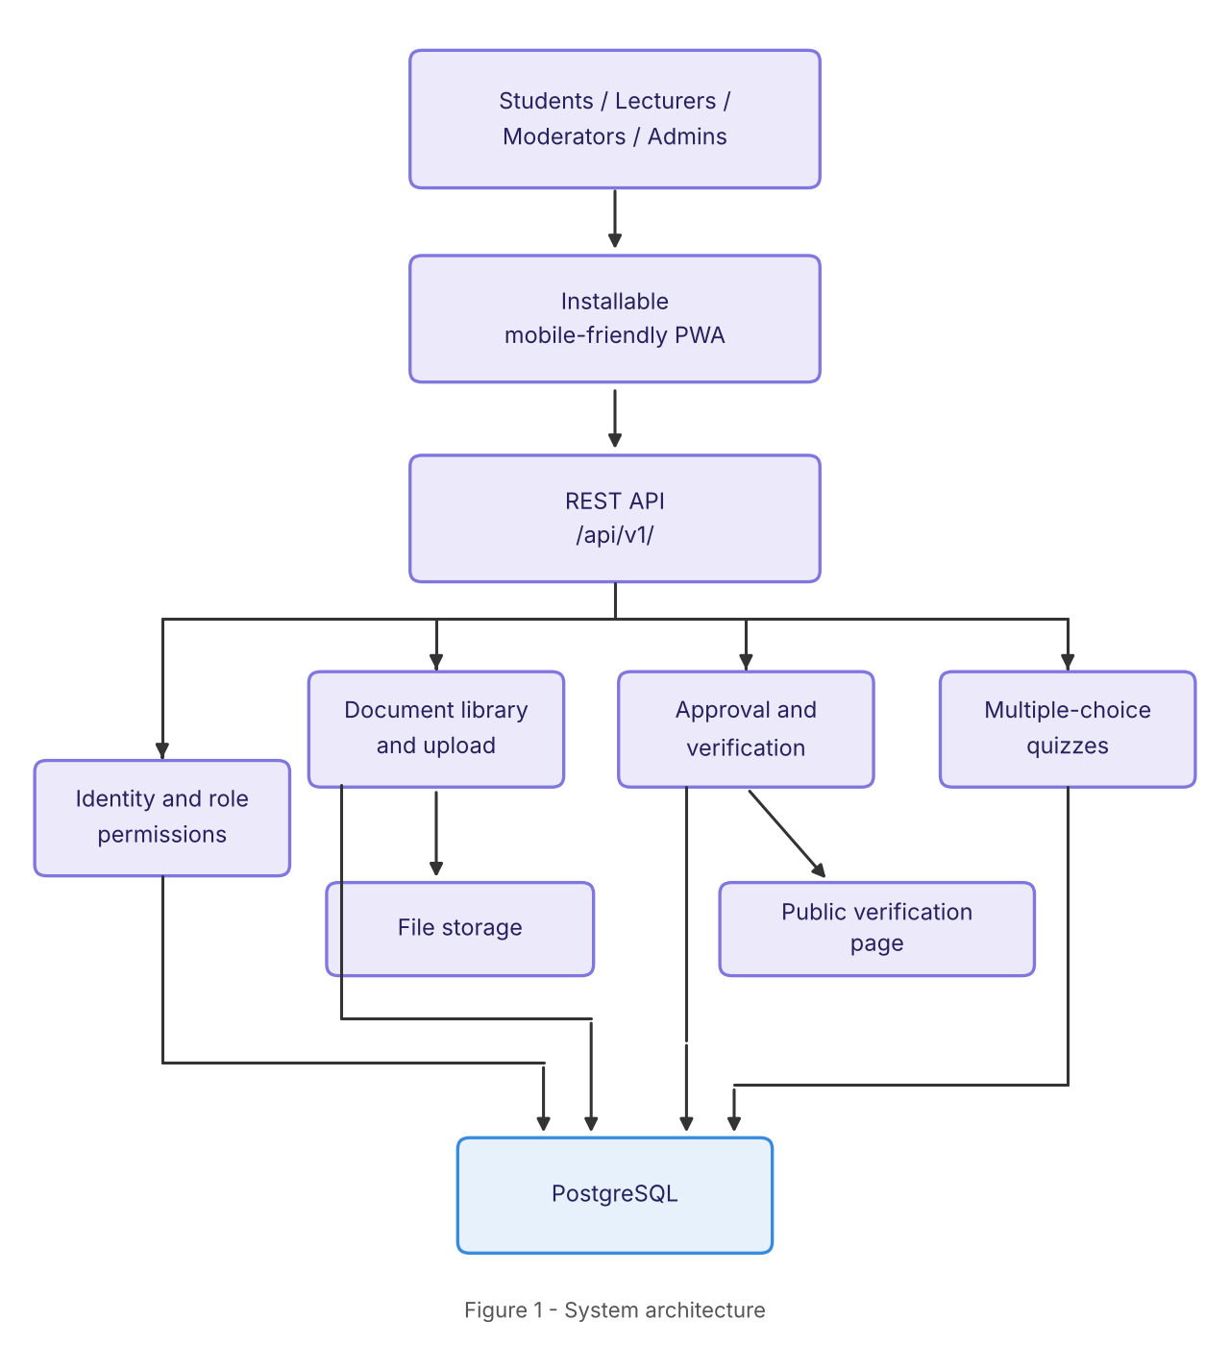

3. API Conventions
- Format: JSON over HTTPS; UTF-8; field names in snake_case; timestamps in ISO 8601 UTC.
- Versioning: major version in the path (/api/v1/). Breaking changes ship as /api/v2/.
- Authentication: short-lived JWT access token (Authorization: Bearer <token>) plus rotating refresh token.
- Authorisation: role-based (student, lecturer, moderator, admin). Each endpoint lists its minimum role.
- Pagination: ?page=1&page_size=20 (max 100). Responses include meta.total and meta.page.
- Filtering and sorting: ?q=, ?status=, ?sort=-created_at.
- Idempotency: PUT and DELETE are idempotent; POST create endpoints accept an optional Idempotency-Key header.
- Rate limiting: per-user and per-IP; 429 with Retry-After when exceeded. Public verification endpoints are limited more strictly.

3.1 Standard error format
{
"error": {
"code": "validation_error",
"message": "title is required",
"details": [{ "field": "title", "issue": "required" }],
"request_id": "req_8f3a21"
}
}

Status | Code | Meaning
400 | validation_error | Malformed or invalid input
401 | unauthenticated | Missing, invalid or expired token
403 | forbidden | Authenticated but role lacks permission
404 | not_found | Resource does not exist or is not visible to caller
409 | conflict | Duplicate or invalid state transition
413 | file_too_large | Upload exceeds the size limit
422 | unprocessable | Valid syntax but fails business rules
429 | rate_limited | Too many requests
500 | server_error | Unexpected failure

4. Resource Overview
Module | Resource | Description
Identity and roles | users, roles, sessions | Accounts, role assignment, login sessions
Document library | documents, document-files, categories | Metadata, uploaded files, subject and course grouping
Approval and verification | approvals, verifications | Moderation workflow and public authenticity checks
Quizzes | quizzes, questions, attempts | Multiple-choice quiz definition, delivery and scoring

5. Endpoint Contracts

5.1 Identity and Role Permissions
Method | Path | Access | Purpose
POST | /auth/register | Public | Create a student account
POST | /auth/login | Public | Exchange credentials for access and refresh tokens
POST | /auth/refresh | Public | Rotate tokens
POST | /auth/logout | Any | Revoke the refresh token
GET | /users/me | Any | Current profile and role
PATCH | /users/me | Any | Update own profile
GET | /users | Admin | List users (filter by role, status)
PATCH | /users/{id}/role | Admin | Assign or change role
PATCH | /users/{id}/status | Admin | Activate or suspend account

POST /auth/login
Request { "email": "ada@example.com", "password": "********" }
200 Response { "access_token": "eyJ...", "refresh_token": "rt_...",
"expires_in": 900,
"user": { "id": "usr_01", "name": "Ada K.", "role": "student" } }
Errors 400, 401, 429

5.2 Document Library and Upload
Method | Path | Access | Purpose
GET | /documents | Student+ | List approved documents (search, filter, paginate)
GET | /documents/{id} | Student+ | Document metadata and download link
POST | /documents | Lecturer+ | Create a document record (status: draft)
POST | /documents/{id}/file | Lecturer+ | Upload the file (multipart/form-data)
PATCH | /documents/{id} | Owner, Mod | Edit metadata
DELETE | /documents/{id} | Owner, Admin | Remove document and stored file
GET | /documents/{id}/download | Student+ | Signed, time-limited download URL
GET | /categories | Student+ | Subjects and course groupings

POST /documents
Request { "title": "CSC 301 Lecture Notes", "category_id": "cat_12",
"description": "Week 1-6", "tags": ["networks"] }
201 Response { "id": "doc_77", "status": "draft", "title": "CSC 301 Lecture Notes",
"owner_id": "usr_09", "created_at": "2026-10-27T09:50:00Z" }
Errors 400, 401, 403, 422

Upload rules (draft): PDF, DOCX, PPTX; maximum 20 MB; server-side type and size check; files stored outside the database with only the storage key kept in PostgreSQL.

5.3 Approval and Verification
Method | Path | Access | Purpose
POST | /documents/{id}/submit | Owner | Submit draft for review (draft to pending)
GET | /approvals | Moderator+ | Review queue (filter by status)
POST | /approvals/{id}/approve | Moderator+ | Approve; issues a verification code
POST | /approvals/{id}/reject | Moderator+ | Reject with a required reason
GET | /documents/{id}/approvals | Owner, Mod | Approval history
GET | /verify/{code} | Public | Public verification page data: title, approver, date, status

POST /approvals/{id}/approve
Request { "note": "Content checked against syllabus." }
200 Response { "id": "apr_31", "document_id": "doc_77", "status": "approved",
"verification_code": "AH-7Q2K-91XD",
"verify_url": "https://<host>/verify/AH-7Q2K-91XD" }
Errors 401, 403, 404, 409 (already decided)

Document status flow: draft > pending > approved or rejected. Rejected documents can be edited and resubmitted. GET /verify/{code} returns no private user data.

5.4 Multiple-Choice Quizzes
Method | Path | Access | Purpose
GET | /quizzes | Student+ | List published quizzes
GET | /quizzes/{id} | Student+ | Quiz details (questions without answers)
POST | /quizzes | Lecturer+ | Create a quiz
PATCH | /quizzes/{id} | Owner | Edit or publish or unpublish
POST | /quizzes/{id}/questions | Owner | Add a question with options and correct answer
POST | /quizzes/{id}/attempts | Student+ | Start an attempt
POST | /attempts/{id}/submit | Student | Submit answers; returns score
GET | /attempts/{id} | Student, Owner | Attempt result and review

POST /attempts/{id}/submit
Request { "answers": [ { "question_id": "q_1", "option_id": "o_3" },
{ "question_id": "q_2", "option_id": "o_7" } ] }
200 Response { "attempt_id": "att_5", "score": 8, "total": 10,
"submitted_at": "2026-10-27T10:20:00Z" }
Errors 401, 403, 404, 409 (already submitted), 422

6. Role Access Matrix
Action | Student | Lecturer | Moderator | Admin
Browse and download approved documents | Yes | Yes | Yes | Yes
Upload documents | No | Yes | Yes | Yes
Approve or reject documents | No | No | Yes | Yes
Take quizzes | Yes | Yes | Yes | Yes
Create quizzes | No | Yes | Yes | Yes
Manage users and roles | No | No | No | Yes
Public verification lookup | Yes (no login needed for anyone)

7. OpenAPI Documentation
- Specification: OpenAPI 3.1, generated from route definitions and validation schemas so code and docs cannot drift.
- Served at /api/v1/openapi.json and /api/v1/openapi.yaml.
- Interactive docs (Swagger UI or Redoc) at /api/v1/docs, enabled in development and staging; restricted or disabled in production.
- Reusable components: Error, Pagination, User, Document, Approval, Quiz, Attempt, plus a bearerAuth security scheme.
- Every operation has an operationId, summary, tags (Identity, Documents, Approvals, Quizzes, Verification), request and response examples, and its error responses.
- The spec is validated in CI and used to generate a typed client for the PWA.

7.1 Spec skeleton
openapi: 3.1.0
info:
title: AcademiaHub API
version: 1.0.0
servers:
- url: https://<host>/api/v1
components:
securitySchemes:
bearerAuth: { type: http, scheme: bearer, bearerFormat: JWT }
schemas:
Error:
type: object
required: [error]
properties:
error:
type: object
properties:
code: { type: string }
message: { type: string }
request_id: { type: string }
security:
- bearerAuth: []
paths:
/auth/login:
post:
operationId: login
tags: [Identity]
security: []
requestBody:
required: true
content:
application/json:
schema:
type: object
required: [email, password]
properties:
email: { type: string, format: email }
password: { type: string }
responses:
"200": { description: Tokens issued }
"401": { description: Invalid credentials }

8. Open Items
- Confirm file size limit and allowed file types.
- Decide whether quiz questions can be reused across quizzes.
- Define verification code format and whether codes can be revoked.
- Choose file storage provider and signed-URL lifetime.
- Confirm login method (email, student ID, or both).

